Over The Wire

## Level 5 to Level 6

**Step 1: SSH Login**

**Password:** 4oQYVPkxZ00E005pTW81FB8j8lxXGUQw

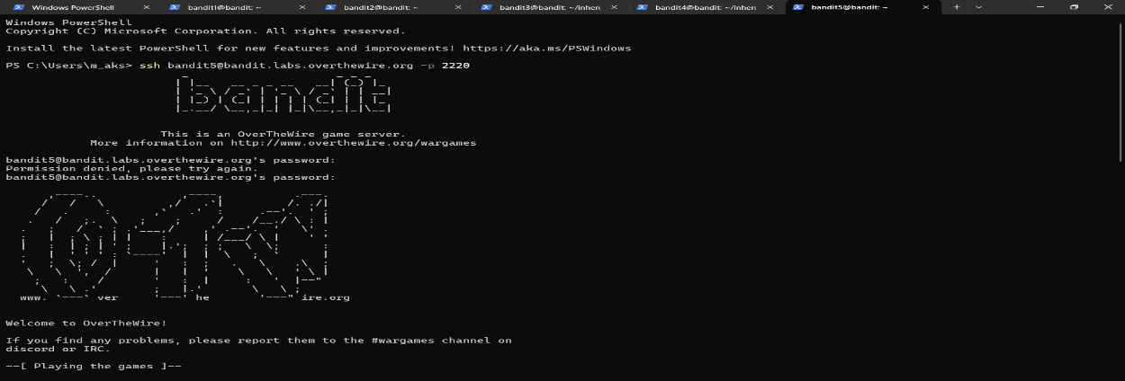

**Step 2: Find the correct file**

find inhere -type f -size 1033c ! -executable

**Step 3: Read the file**

**Cat ./maybehere07/.file2**

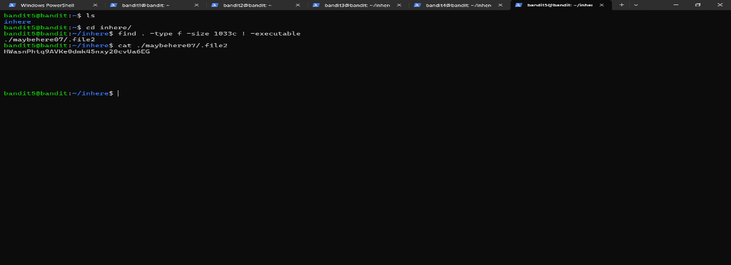

**Password**: HWasnPhtq9AVKe0dmk45nxy20cvUa6EG